# Test Notes

**Test 10/11 — Indoor room scan (controlled artificial light)**

**Capture**

* Two inward‑facing perimeter orbits: ~1.2 m (waist) and ~1.7 m (eye), ~70–80% overlap; extra shots at corners.
* Center rotations for ceiling and floor (~10–15 images each), angled up then down; crouched for floor variation.
* Tripod, slow perimeter moves; camera ~10–15° toward room centre.

**Camera**

* f/5.6, 1/60, ISO 200, WB Auto.

**Markers**

* Full A4, bold “X”.
* ~1.5–2 m spacing on each wall; markers near corners/90° joints.
* Several on floor (taped) and near ceiling; evenly distributed; no duplicates (rotated/labeled).

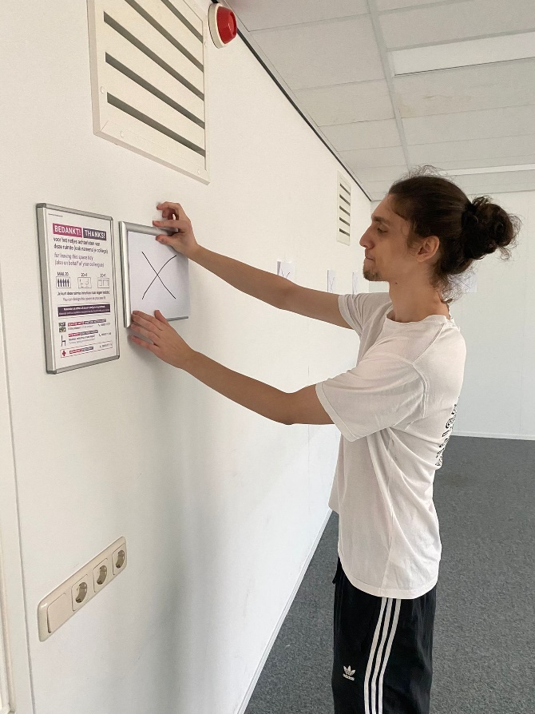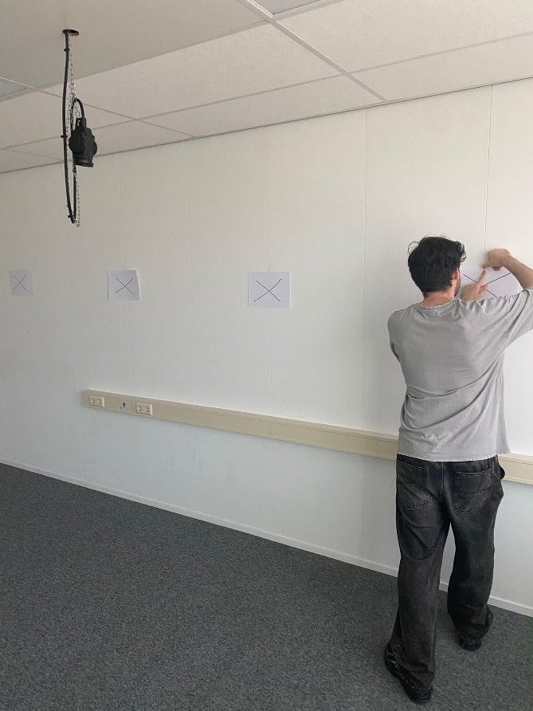

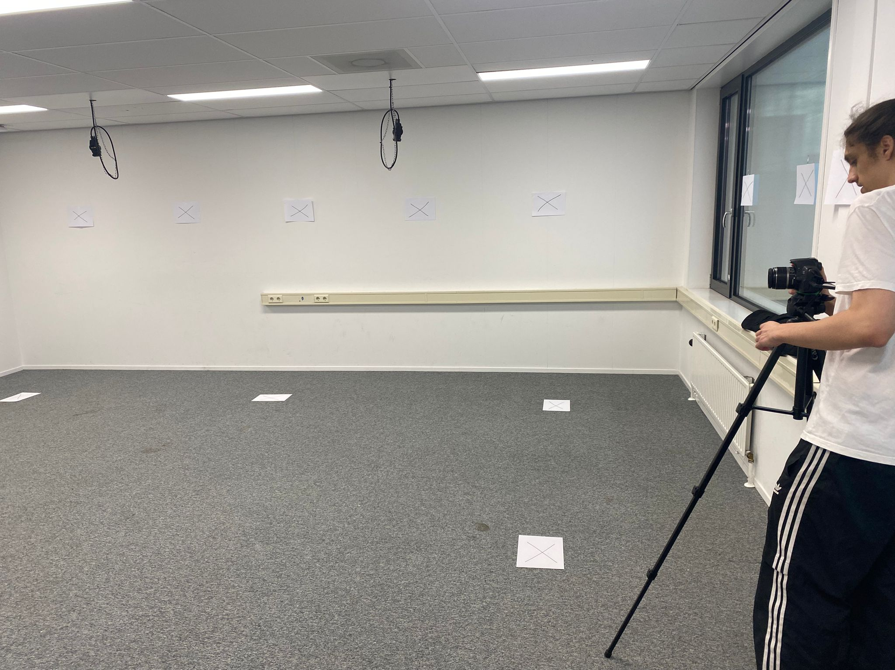

**Meshroom (2025.1.0)**

* FeatureExtraction: Quality High, Density High, Type SIFT only
* DepthMap: Downscale 2, Max Nb Neighbour Cameras 10
* DepthMapFilter: Min Consistent Cameras 4, Bad Similarity 8
* Meshing: Max Input Points 18,000,000; Max Points 3,000,000; Weakly Supported Surface Off
* MeshFiltering: Keep Only the Largest Mesh ON
* Texturing: TextureSize 8192; Texture Downscale 2

**Results**

* Pros: Floor nearly production‑ready; walls sharp and aligned; minimal holes; markers improved structural stability; tripod workflow yielded consistent overlap and clean wall definition.
* Cons/Next: Textures slightly dark (ISO 200, artificial light); white walls show mild noise/softness. Plan to test ISO 400–800, controlled natural‑light variant, and higher meshing for finer detail.

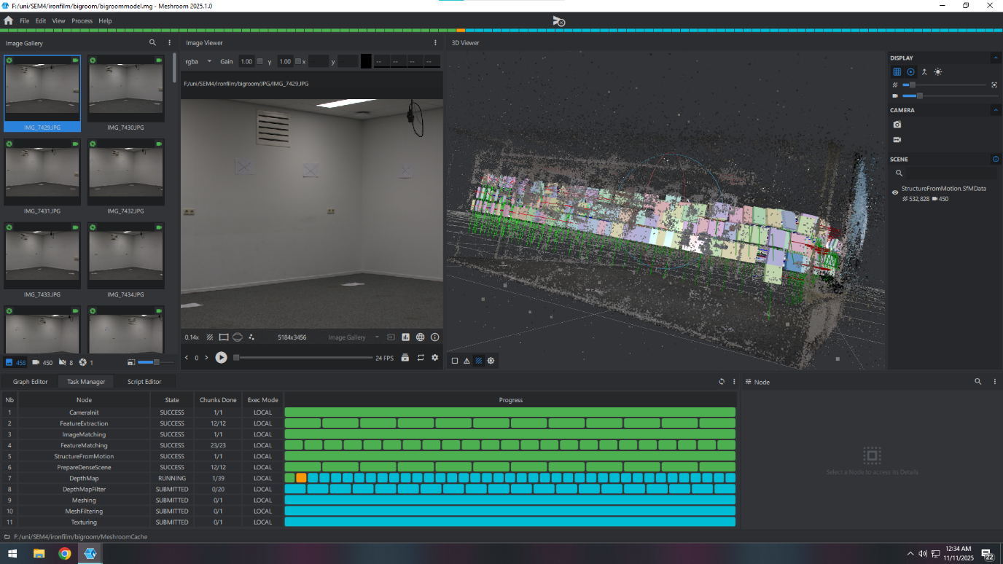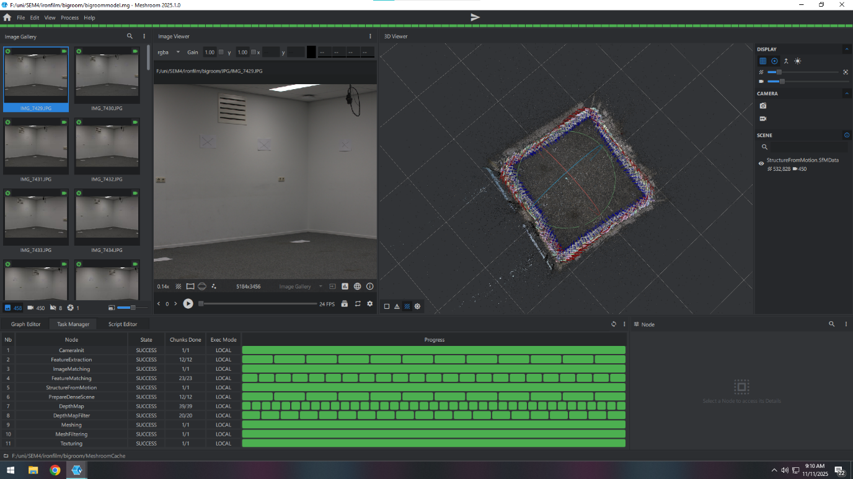

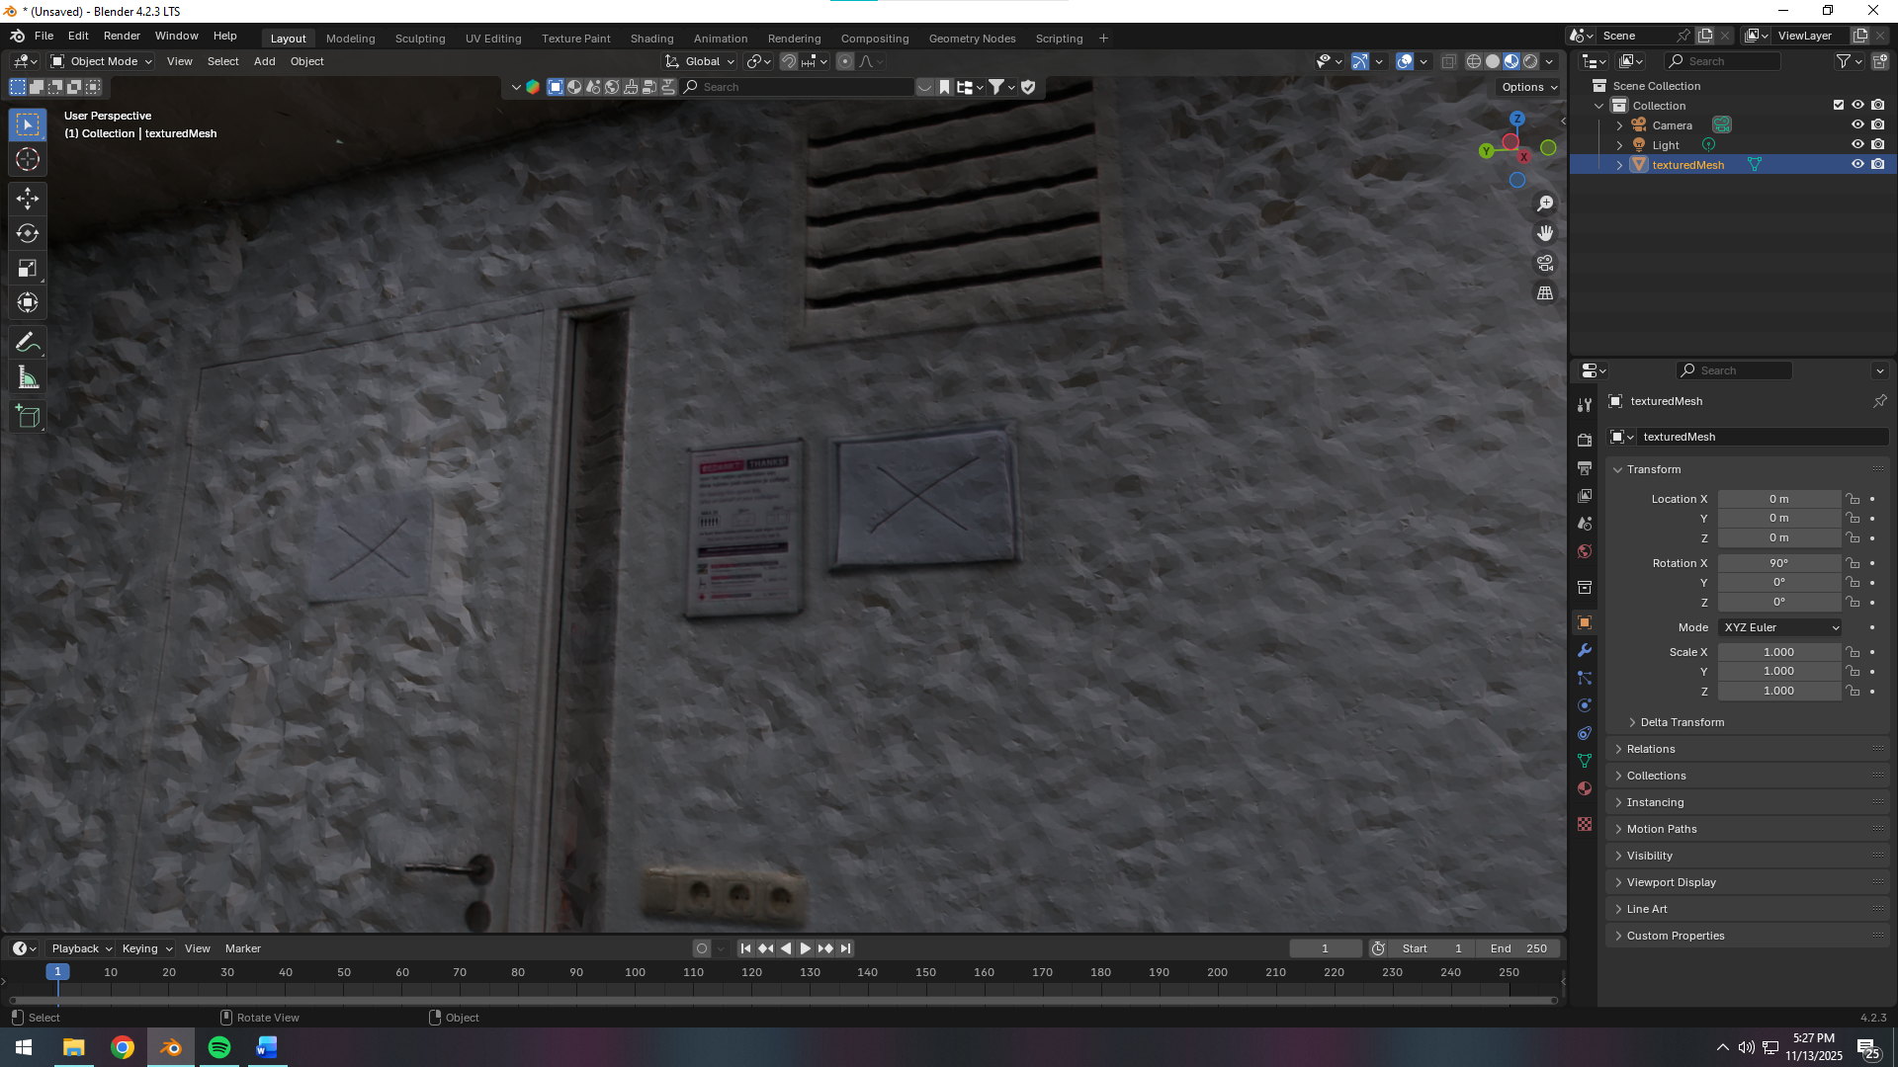

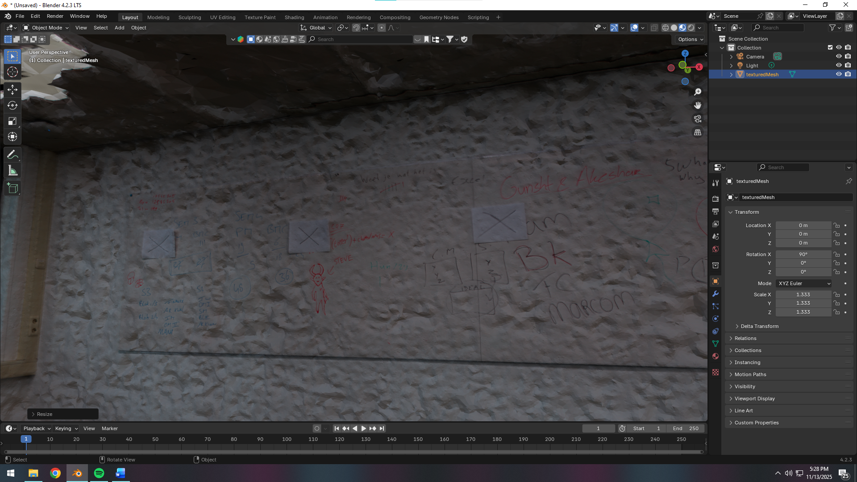

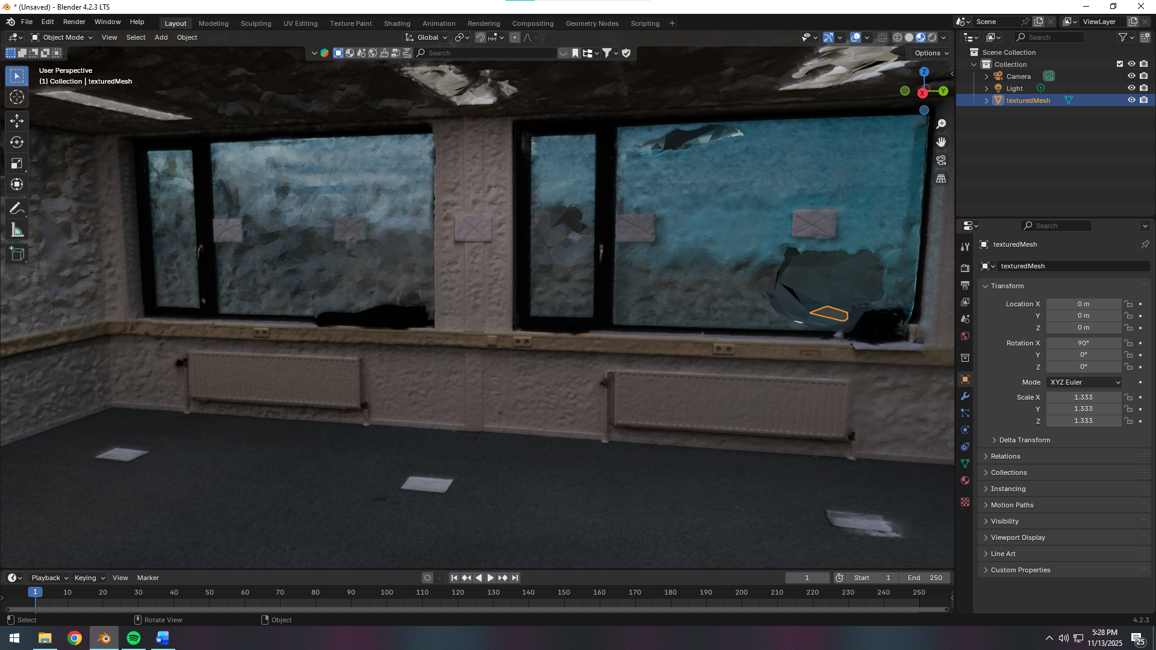

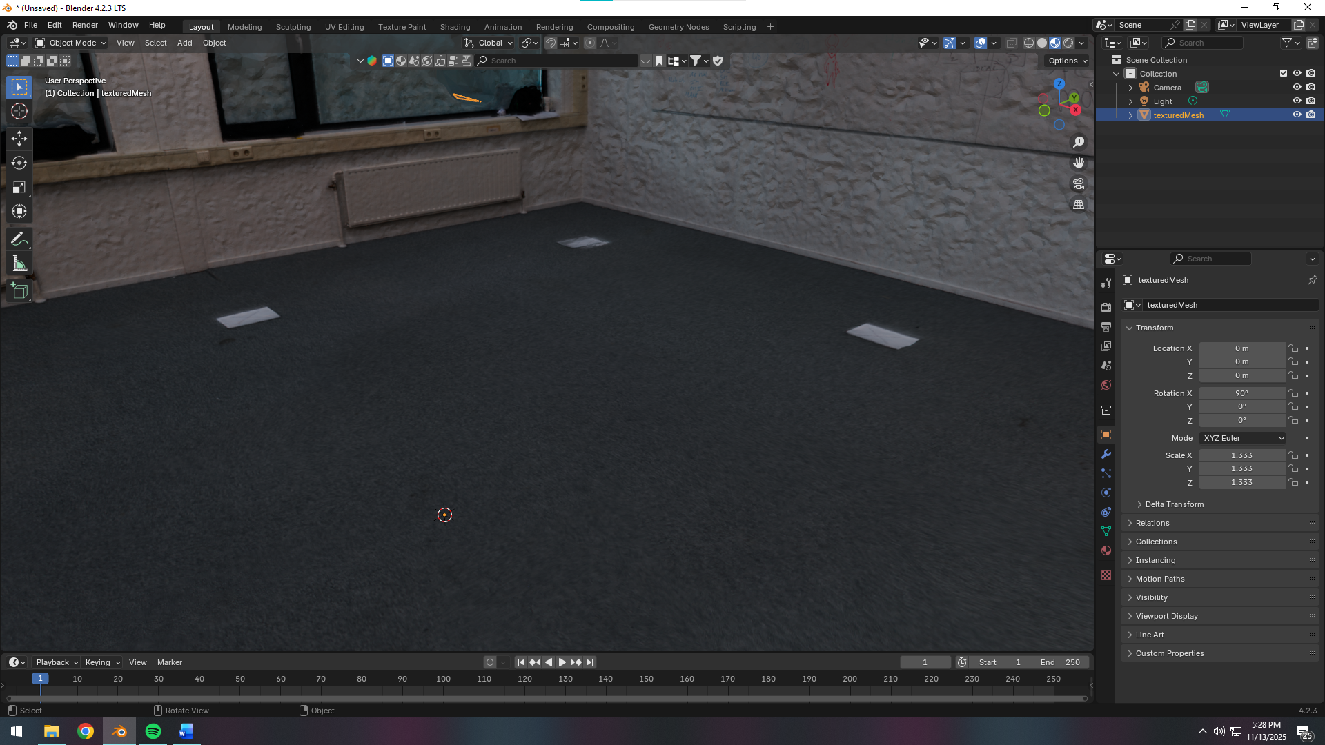

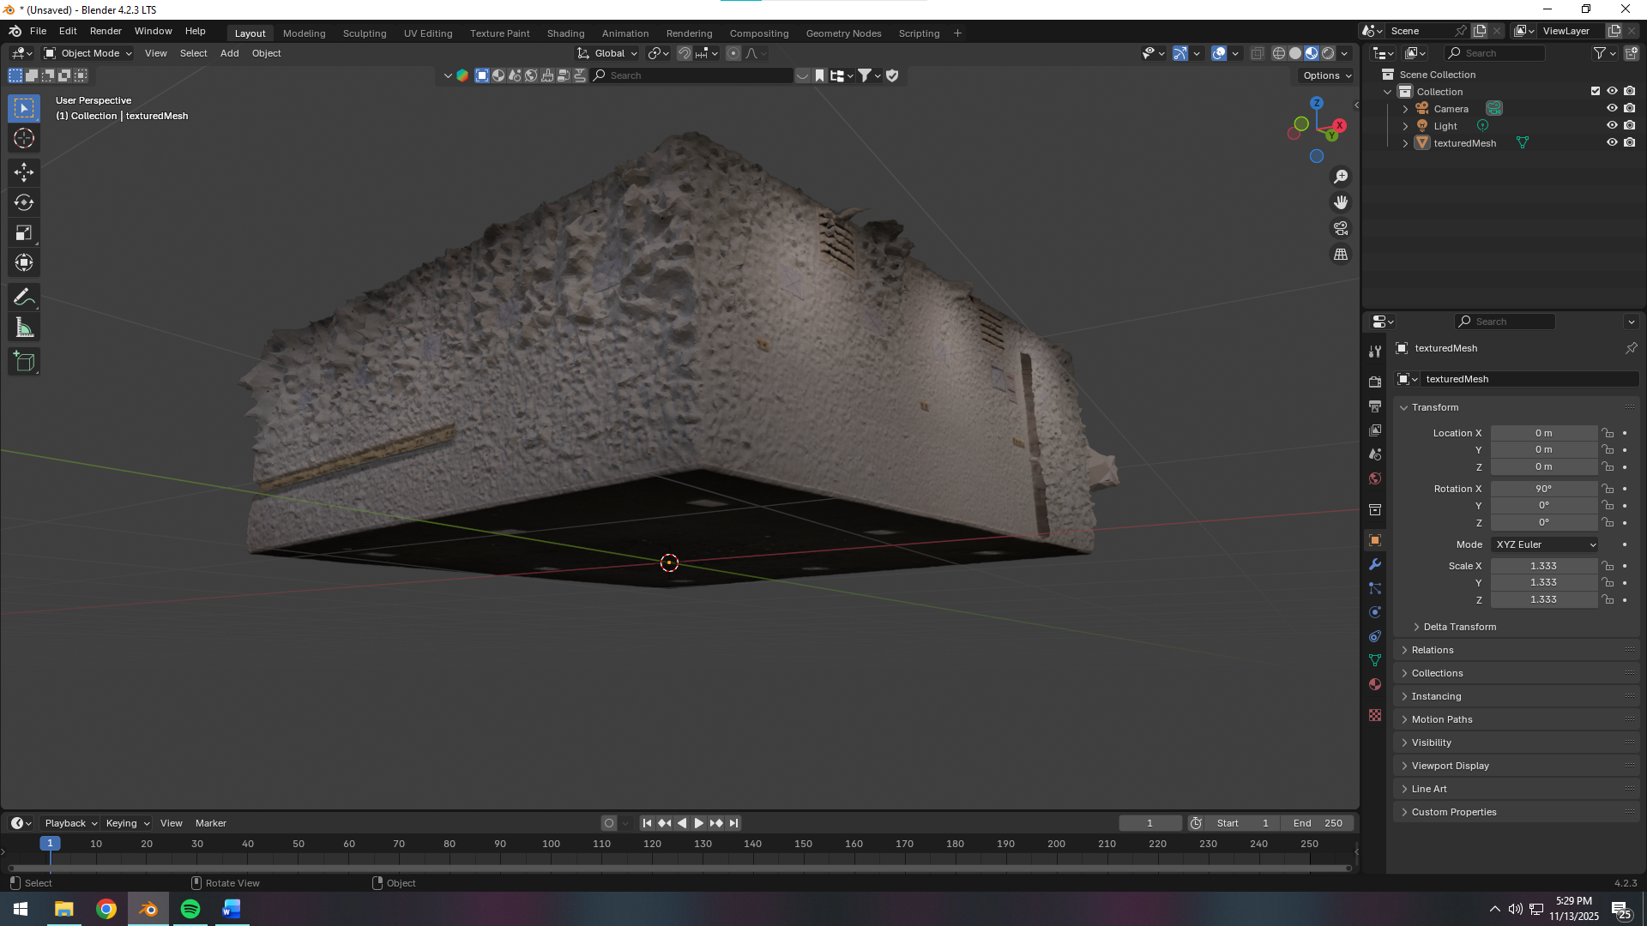

**Test 11/11 — Indoor room scan (higher ISO + daylight WB + ultra settings)**

**Camera**

* f/5.6, 1/60, ISO 400, WB Daylight.

**Room/Markers**

* Same room; printed markers on walls (≈4 per wall); X/circle combos at corners and wall–floor intersections for large uniform areas.

**Capture**

* Same orbital method, two heights (~1.20 m, ~1.70 m), plus floor/ceiling passes with overlap.

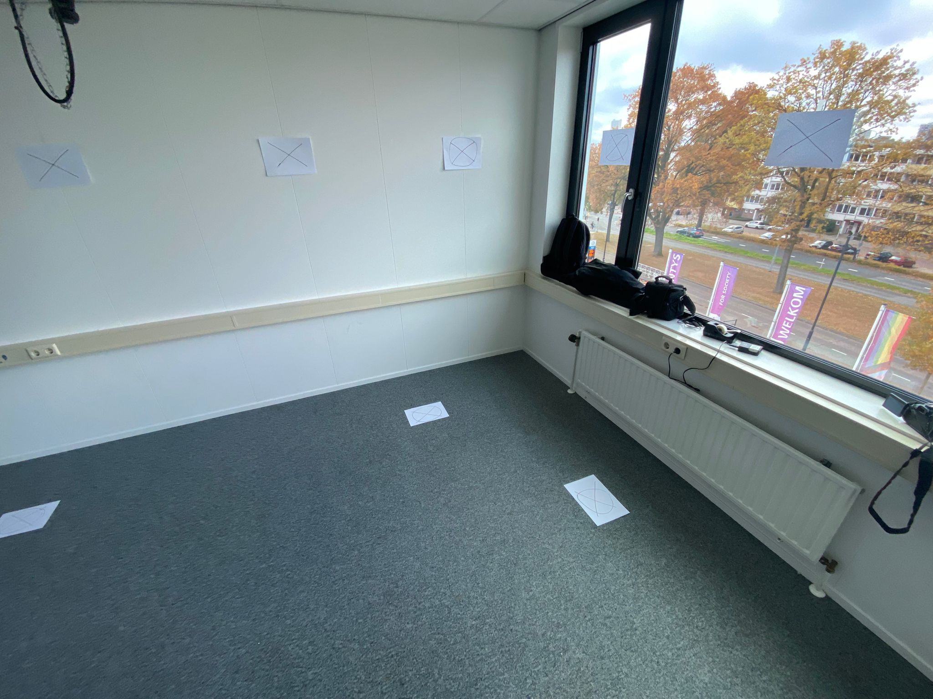

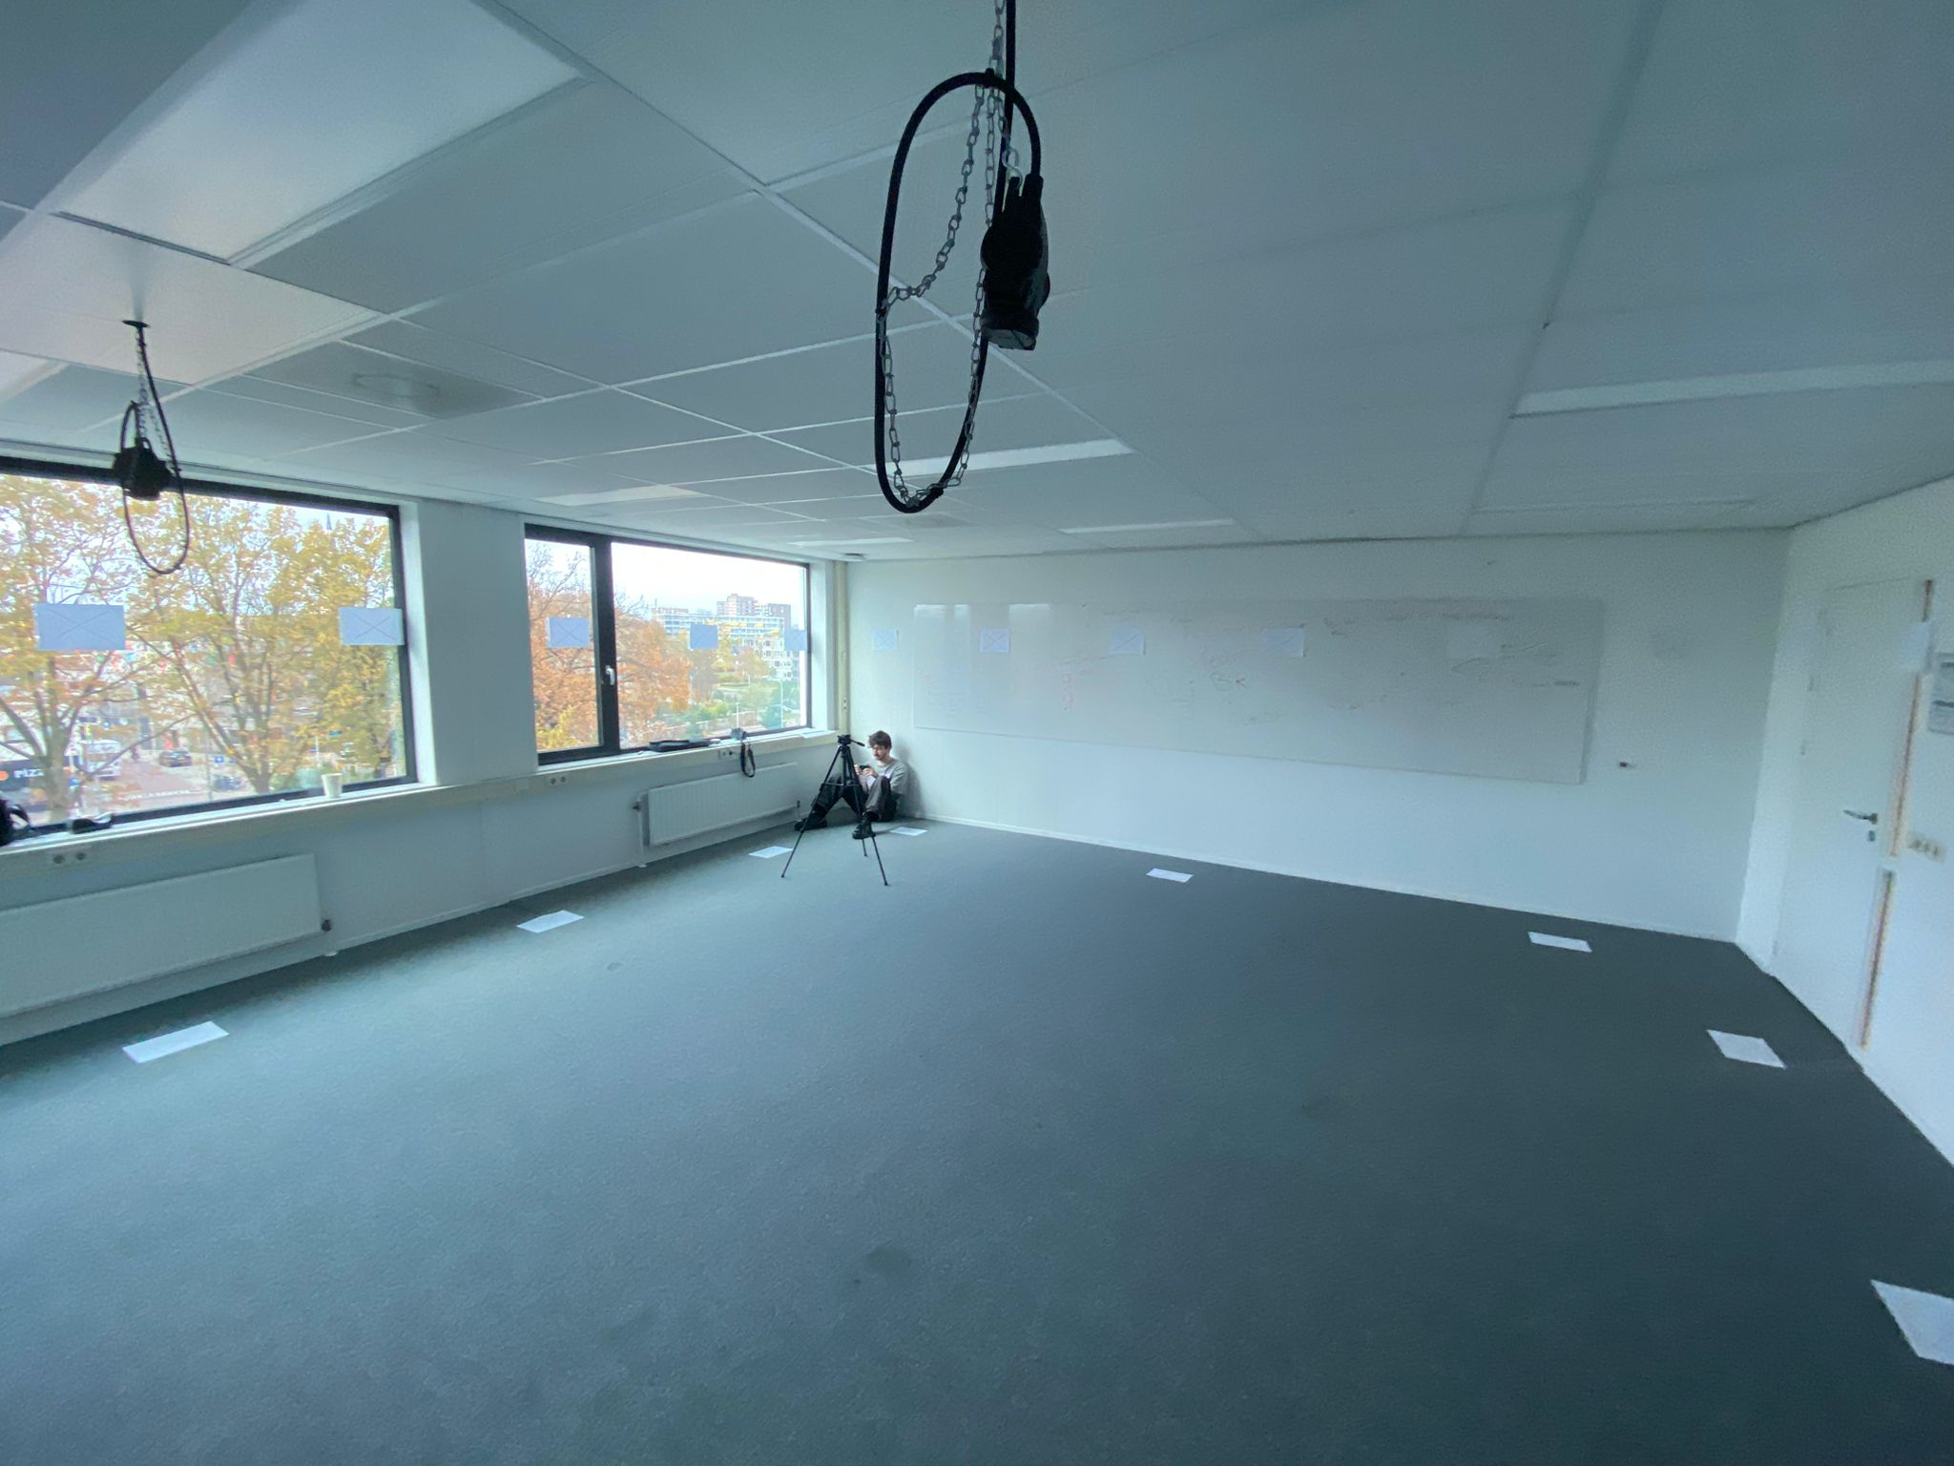

**Processing**

* University workstation; higher computational budget; intent: test denser reconstruction.

**Meshroom**

* FeatureExtraction: Quality Ultra, Describer SIFT only, Density Ultra
* DepthMap: Downscale 1, Max Nb Neighbour Cameras 14
* DepthMapFilter: Min Consistent Cameras 3; Bad Similarity 6
* Meshing: Max Input Points 25,000,000; Max Points 5,500,000; Weakly Supported Surface Off
* MeshFiltering: Keep Only the Largest Mesh ON
* Texturing: Texture Size 8192
* **Results**
* Visual quality worse than Test 10/11: noisier, slight green cast, flatter textures, less distinct surfaces despite higher settings.
* Likely causes: higher ISO noise; mixed/uneven lighting; WB mismatch leading to inconsistent color and reduced contrast. Feature detection suffered; depth data noisier.

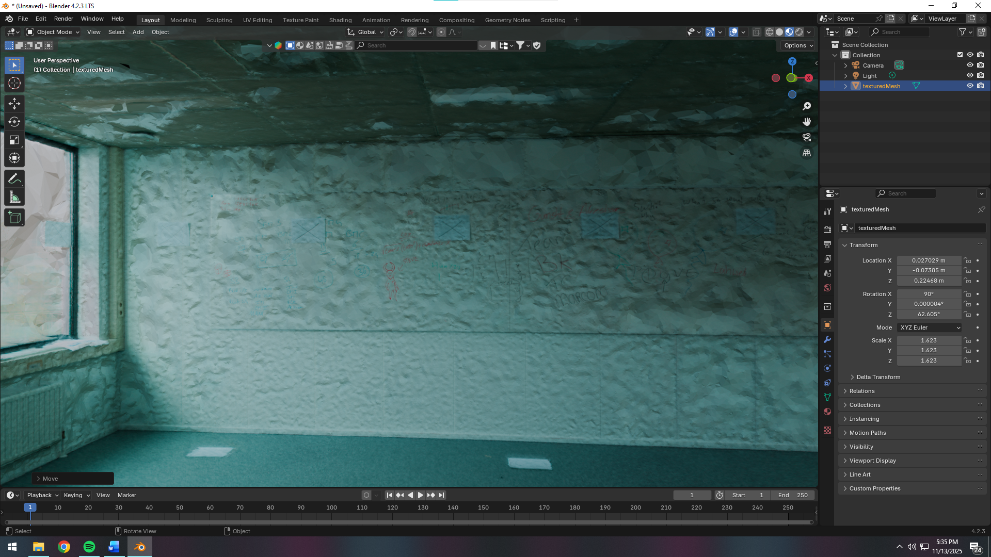

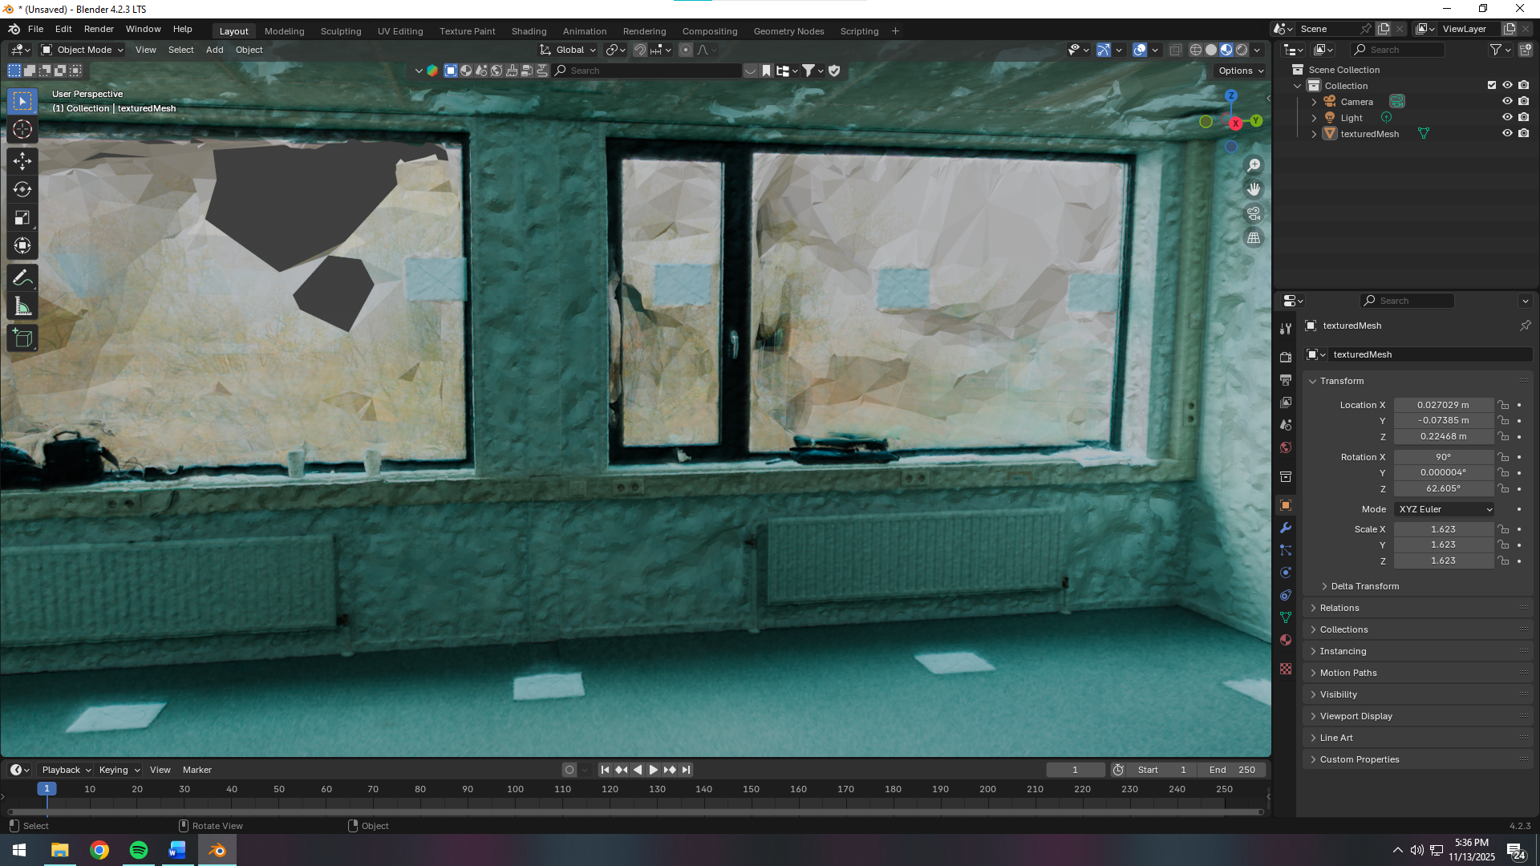

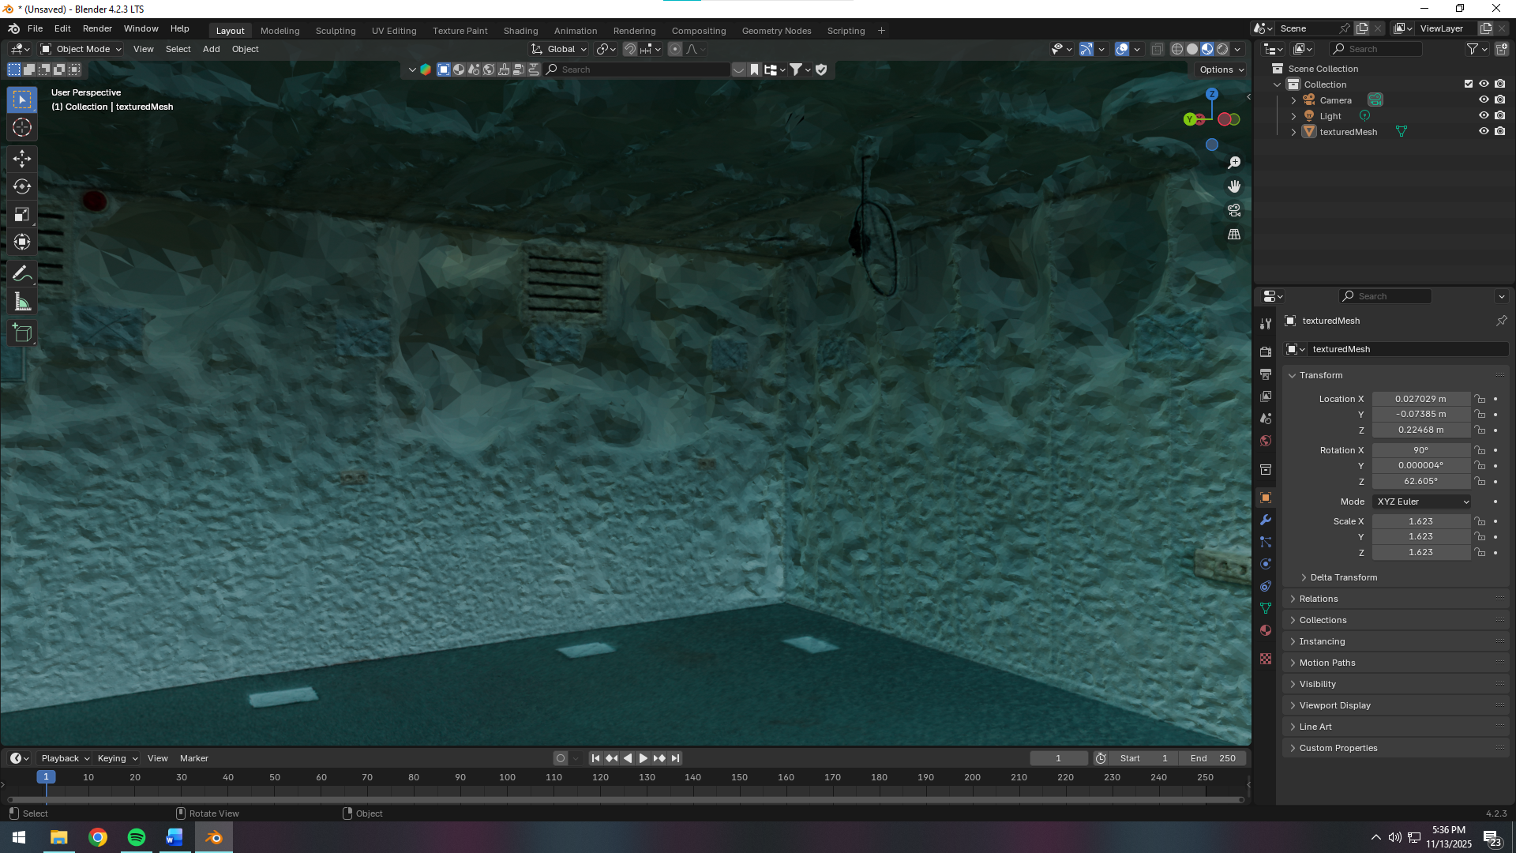

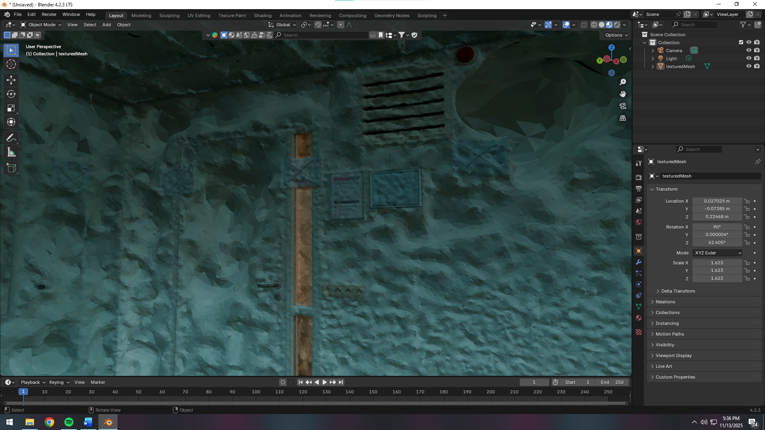

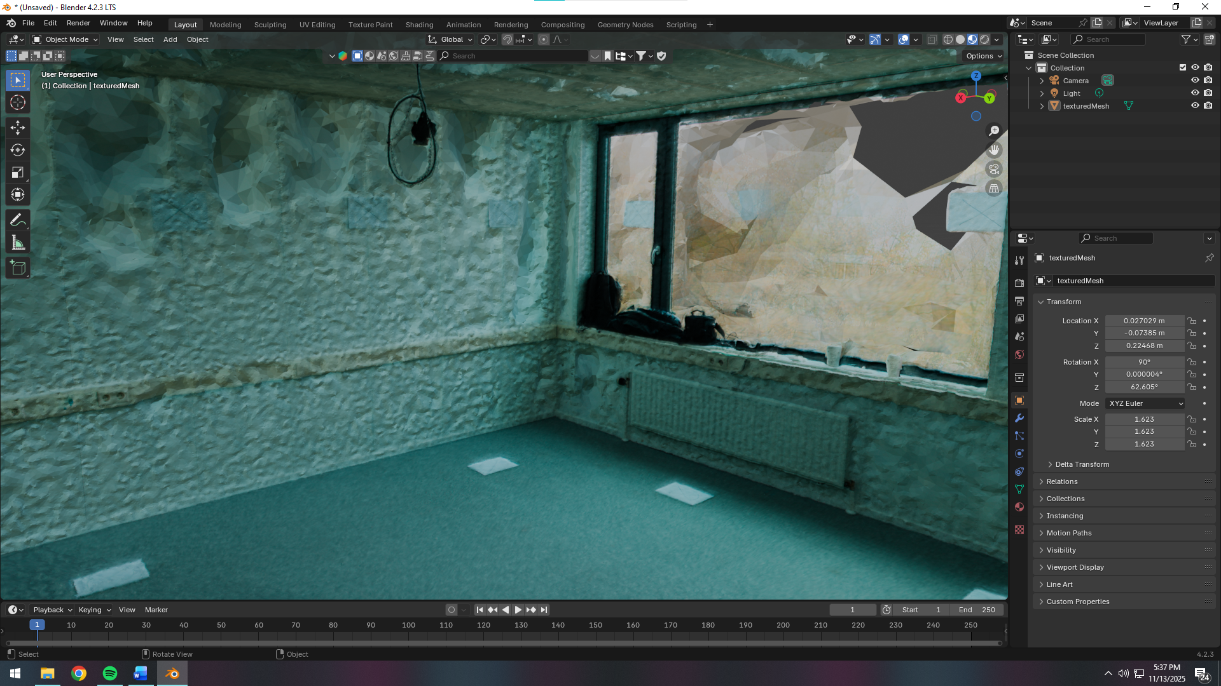

**Conclusion across tests**

* Clean, consistent input images dominated outcomes. Low ISO, controlled lighting, and stable WB produced the best geometry and textures.
* Raising Meshroom quality improved results only when input images were already clean; with noisy/mixed lighting, higher settings amplified issues.
* The inward‑facing two‑height orbit plus center ceiling/floor passes remained robust across both tests; markers materially improved alignment on uniform walls.

**Next steps**

* Lock a single light type and WB; avoid mixed/daylight spill.
* Keep ISO 100–200; match exposure across all images.
* Retest with same capture path and markers; then increase meshing/neighbor parameters once inputs are clean.
* Produce side‑by‑side outputs (Test 10/11 vs 11/11) to illustrate lighting/ISO impact for the report.